ABC’s Inventory Management System

Manage Product (Delete Product) Test Scripts

Table of Contents

DPT001- Delete a product from the database 2

Set 1 3

Set 2 4

# DPT001- Delete a product from the database

|  |  |  |  |  |  |
| --- | --- | --- | --- | --- | --- |
| **Test Name** | | Test delete a product from the database (Test DPT001) | | | |
| **Use Case Tested** | | Manage Product | | | |
| **Test Description** | | This test tests if the system can delete a product from the database. | | | |
| **Pre-Conditions** | | Users need be logged in as a Warehouse Staff (Warehouse Staff Access) in the Manage Product page  Meta data to store Product details in the database must exist. | | | |
| **Post-Conditions** | | Product is deleted | | | |
| **Result (Pass/Fail/Warning/ Incomplete)** | | Pass | | | |
|  | **Test Step** | | **Expected Test Results** | **P** | **F** |
| 1. | Click on ‘Delete’ icon at ‘Manage Product’. | | System prompts user to confirm deletion of the product. | P |  |
| 2. | Click on ‘Yes’ | | System deletes the product and displays an appropriate message. | P |  |

## Set 1

**Step 1**

Manage Product Page

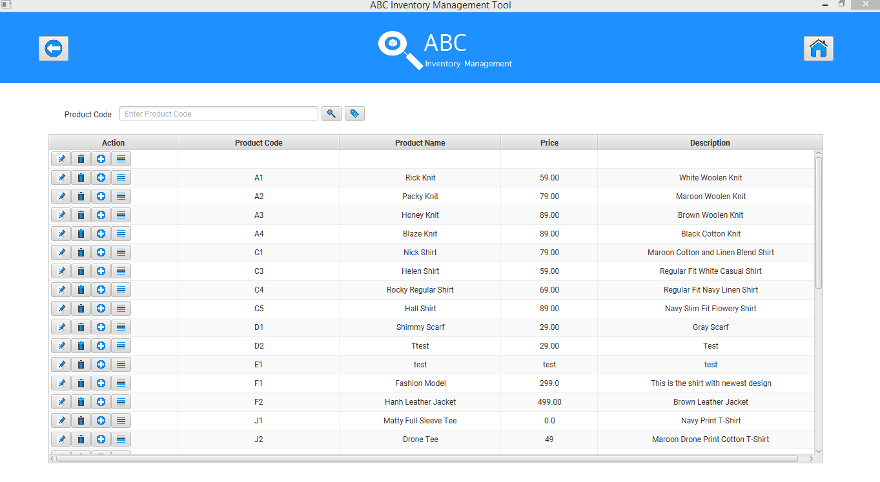

System prompting user to confirm deletion of product ‘L1’

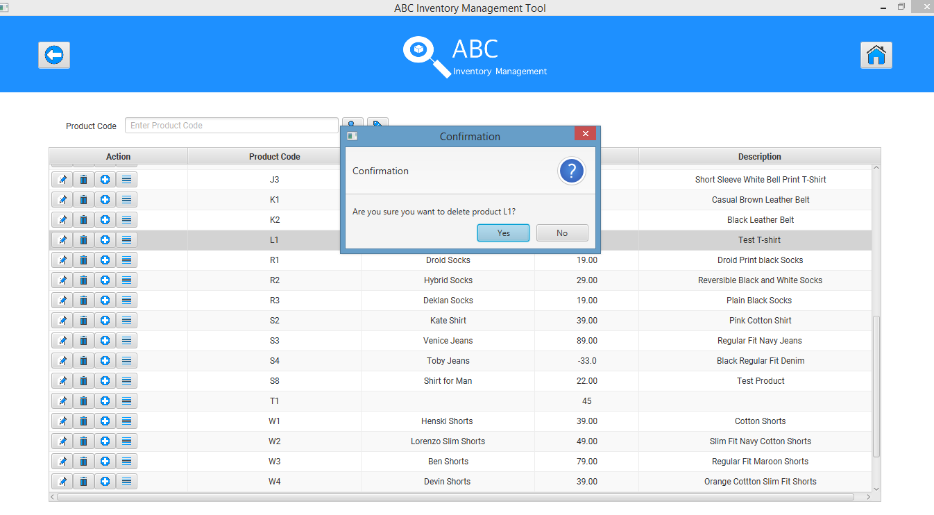

**Step 2**

System displaying an appropriate message.

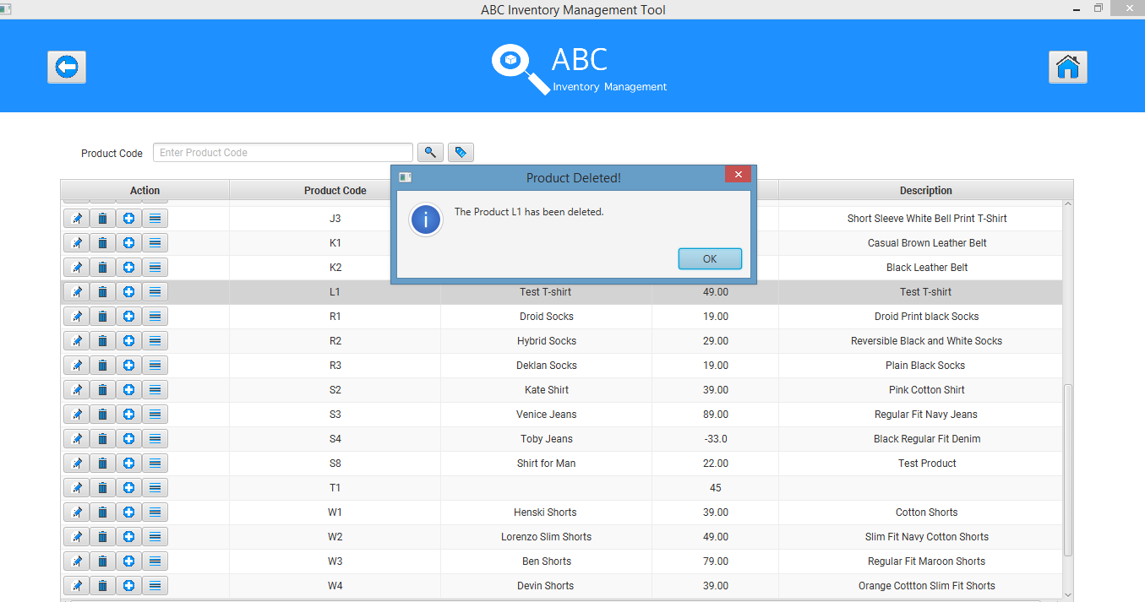

## Set 2

**Step 1**

Manage Product Page



System prompting user to confirm deletion of product ‘D2’

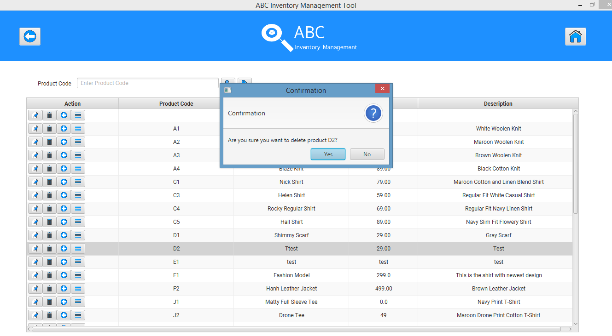

**Step 2**

System displaying an appropriate message.

